**R Assignment 1**

**Sean Parrell**

**9/4/2024**

**Problem:**

Create a unique dataset and compute the following statistics: sample mean, median, 10% trimmed mean, and the 35th percentile. Then, plot a histogram and describe the shape of the data.

**Solution**

**Step 1: Set a unique seed number**

We start by setting the unique seed number to make a reproducibility of the results. The seed number used here is **49674969** (My UFID Number):

# Set a unique seed number

set.seed(49674969)

**Step 2: Generate a dataset of 100 random numbers**

The dataset is generated using the rnorm() function, with a mean of 30 and a standard deviation of 2.

# Generate a dataset of 100 random numbers from a normal distribution

mydata <- rnorm(100, mean = 30, sd = 2)

**Step 3: Calculate sample mean, median, 10% trimmed mean, and the 35th percentile**

# Sample Mean

mean_value <- mean(mydata)

# Sample Median

median_value <- median(mydata)

# 10% Trimmed Mean

trimmed_mean <- mean(mydata, trim = 0.1)

# 35th Percentile

percentile_35 <- quantile(mydata, probs = 0.35)

# Output of the values

mean_value

median_value

trimmed_mean

percentile_35

**Results:**

* **Sample Mean**: 29.92115
* **Sample Median**: 30.08911
* **10% Trimmed Mean**: 29.95237
* **35th Percentile (35%)**: 28.93813

**Step 4: Plot a histogram of the data**

We generate a histogram to visualize the distribution of the data:

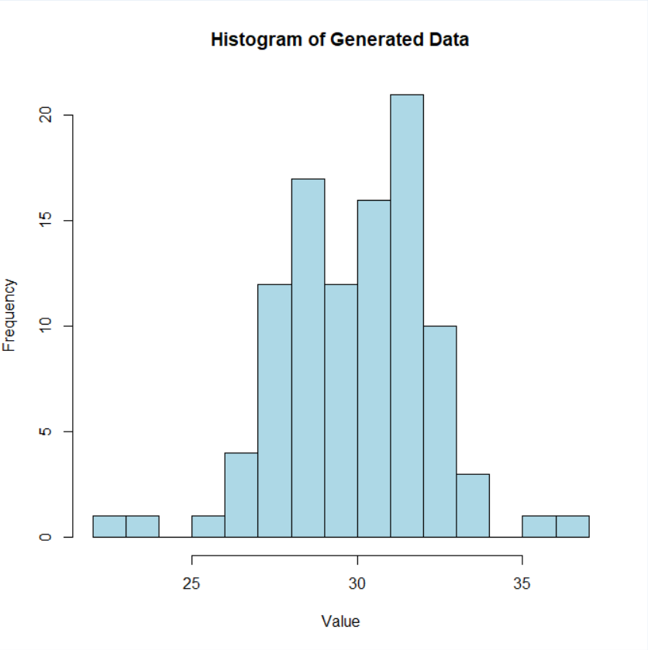

**Interpretation:**

The histogram shows that the generated data is approximately normally distributed, with the center around the mean of 30. The data is symmetric and bell-shaped, indicating that the distribution of the values follows the characteristics of a normal distribution, which was expected given the use of the rnorm() function with a specified mean and standard deviation.

**Conclusion:**

In this assignment, we successfully generated a dataset using a normal distribution, calculated key statistics (mean, median, trimmed mean, percentile), and visualized the data through a histogram. The results confirm that the generated data closely follows a normal distribution, as shown by the histogram and calculated values.